

DATA ANALYST BOOTCAMP | GEN 2

SQL UNIT SUMMARY PROJECT

Quito, Ecuador

05-June-2024

**INDEX**

**MEMBERS 3**

**OVERVIEW 4**

**PROJECT OBJECTIVES 5**

**SCOPE 6**

**SQL CODE 7**

Principal Queries 7

1. First & Second Question 7

2. Third Question 10

3. Sub-questions 12

● 01 12

● 02 14

● 03 15

● 04 16

● 05 17

● 06 17

Secondary Queris 18

**CONCLUSION 34**

# MEMBERS

* David Cascante
* Alex Vallejo
* Mateo Llerena
* Jeyson Mueses

# OVERVIEW

In this project, we analyze the “Adventure Works 2022” database, which represents a fictitious multinational company dedicated to the manufacture of bicycles and cycling-related items. The database consists of 71 tables, each representing different aspects of the company, following a relational model.

The initiative for this project arises from the final work of the SQL module in the Data Analysis Bootcamp taught by Kruger School X.

During the modules, we will explore information analyzed and documented using the data query language “SQL”. Through statistical graphs, we will seek to answer the questions raised by the project, reflecting conclusions and recommendations based on the data. The objective is to understand how a company's internal data works, applying the knowledge acquired during the Bootcamp.

# PROJECT OBJECTIVES

* Identify and analyze seasonal patterns in revenue and profitability
* Perform customer segmentation analysis to customize sales and marketing strategies.
* Evaluate the performance of implemented recommendations over time and make adjustments as necessary to ensure long-term profitability objectives are met
* Perform a long-term trend analysis to determine if there is an upward or downward trend in the company's financial data over the previous months and years.

# SCOPE

**The scope is based on answering the following questions**

* Is the revenue/profitability seasonal?

(Choose what to examine: revenue or profitability or both.)

* Is there an upward or downward trend in the company's data over the months and years?

(Choose what to examine: revenue or profitability or both.)

* Choose one topic that affects the company's profitability, study it and give recommendations based on data for how to improve the company's profitability

**And the following sub-questions**

* What is the total revenue/profit?
* What is the average of the discounts on a single item?
* What is the quantity of items purchased?
* How much is the margin (sale price less cost)?
* What are the monthly and quarterly rankings for the year according to the margin (sale less cost)?

**Disclaimer:** If during the presentation more questions arise that are not in the scope of the project, a second phase of analysis will be carried out.

# SQL CODE

## Principal Queries

### **First & Second Question**

* **/*For this question, we are going to analyze both revenue and historical profitability**

**of the company. Data will be analyzed by years and months.*/**

* **/*First we analyze the Income (Sales)*/**
* **/*This query gives me the Big Picture of the monthly accumulated income (Sales) history*/**

SELECT

--YEAR(soh.OrderDate) AS Año,

MONTH(soh.OrderDate) AS Mes,

SUM (case when year(soh.OrderDate) = 2011 then (sod.UnitPrice * sod.OrderQty)end) AS Ingresos2011,

SUM (case when year(soh.OrderDate) = 2012 then (sod.UnitPrice * sod.OrderQty)end) AS Ingresos2012,

SUM (case when year(soh.OrderDate) = 2013 then (sod.UnitPrice * sod.OrderQty)end) AS Ingresos2013,

SUM (case when year(soh.OrderDate) = 2014 then (sod.UnitPrice * sod.OrderQty)end) AS Ingresos2014

FROM

Sales.SalesOrderHeader AS soh

JOIN Sales.SalesOrderDetail AS sod

ON soh.SalesOrderID = sod.SalesOrderID

GROUP BY

/*YEAR(soh.OrderDate),*/MONTH(soh.OrderDate)

ORDER BY

Mes

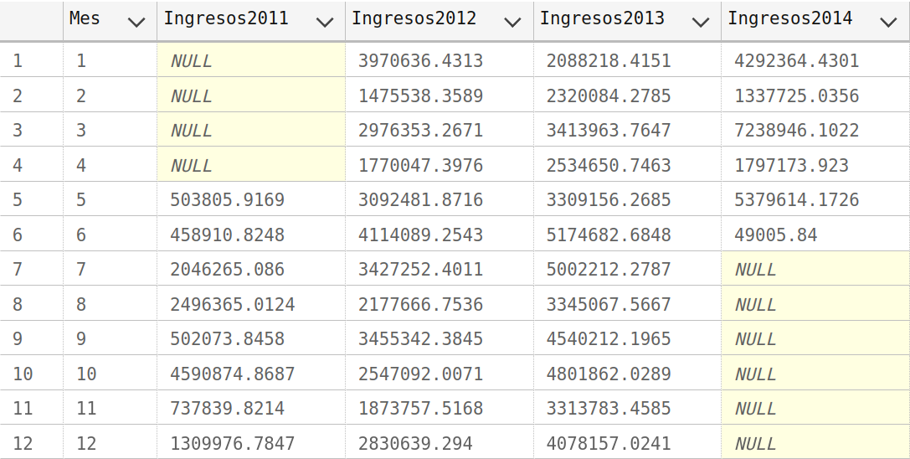

* **/*Now we analyze profitability*/**
* **/*These Queries are to check if the ListPrice of the product table is equal to the UnitPrice of the table detail. But it is observed that NO. There are values ​​that differ in both tables*/**

SELECT ProductID, UnitPrice, UnitPriceDiscount

from Sales.SalesOrderDetail

where ProductID in (777,800,854)

select* --ProductID, StandardCost,ListPrice

from Production.Product

where ProductID in (777,800,854)

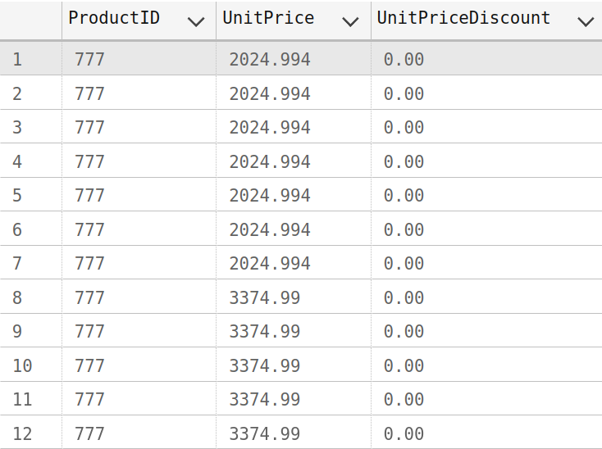

* **/*This query gives me the Big Picture of the monthly accumulated Profit history*/**

SELECT

--YEAR(soh.OrderDate) AS Año,

MONTH(soh.OrderDate) AS Mes,

SUM (case when year(soh.OrderDate) = 2011 then (sod.LineTotal - p.StandardCost * sod.OrderQty)end) AS Profit2011,

SUM (case when year(soh.OrderDate) = 2012 then (sod.LineTotal - p.StandardCost * sod.OrderQty)end) AS Profit2012,

SUM (case when year(soh.OrderDate) = 2013 then (sod.LineTotal - p.StandardCost * sod.OrderQty)end) AS Profit2013,

SUM (case when year(soh.OrderDate) = 2014 then (sod.LineTotal - p.StandardCost * sod.OrderQty)end) AS Profit2014

FROM

Sales.SalesOrderHeader AS soh

JOIN Sales.SalesOrderDetail AS sod

ON soh.SalesOrderID = sod.SalesOrderID

JOIN Production.Product AS p

ON sod.ProductID = p.ProductID

GROUP BY

/*YEAR(soh.OrderDate),*/MONTH(soh.OrderDate)

ORDER BY

Mes

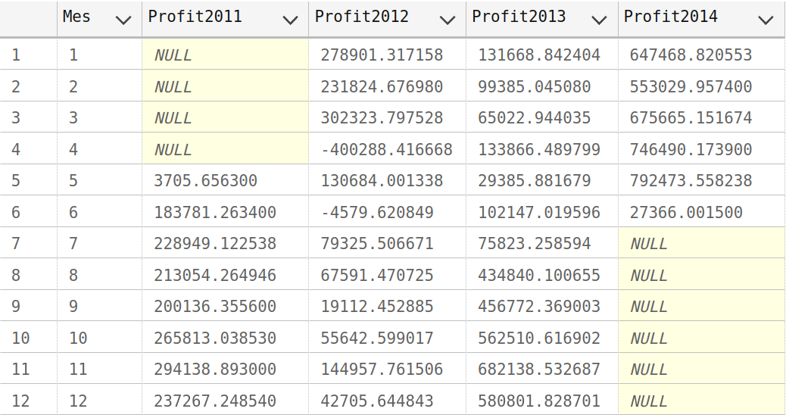

### **Third Question**

**/*Query to analyze sales by buyer, territory with the total sales of products purchased and by stores, more information can be broken down by dates, countries and regions*/**

SELECT

SC.CustomerID,PP.[LastName],PP.[FirstName],

COUNT(SSOH.SalesOrderID) Q_SalesOrders,

COUNT(PROD.[Name]) AS Q_ProductName,

SUM(SSOD.OrderQty) AS SUM_ProductVend,

SUM(SSOH.SubTotal) AS SUM_Ventas,

SUM(SSOH.SubTotal)/SUM(SSOD.OrderQty) AS Consumo_Prom_Product,

SUM(SSOH.SubTotal)/COUNT(SSOH.SalesOrderID) AS Cheque_Prom_Orden,

SS.[Name] AS StoreName,

SST.[Name],SST.CountryRegionCode

FROM

Sales.Customer SC

LEFT JOIN Person.Person PP

ON SC.PersonID = PP.BusinessEntityID

LEFT JOIN Sales.SalesOrderHeader SSOH

ON SC.CustomerID = SSOH.CustomerID

LEFT JOIN Sales.SalesOrderDetail SSOD

ON SSOH.SalesOrderID = SSOD.SalesOrderID

LEFT JOIN Production.Product PROD

ON PROD.ProductID = SSOD.ProductID

LEFT JOIN Sales.SalesTerritory SST

ON SST.TerritoryID = SC.TerritoryID

LEFT JOIN Sales.Store SS

ON SC.StoreID = SS.BusinessEntityID

/*WHERE SST.CountryRegionCode = 'CA' AND YEAR(SSOH.OrderDate) = 2012*/

GROUP BY

SC.CustomerID,PP.[LastName],PP.[FirstName],

SS.[Name],

SST.[Name],SST.CountryRegionCode

ORDER BY

Q_ProductName DESC, SC.CustomerID,PP.[LastName] , PP.[FirstName]

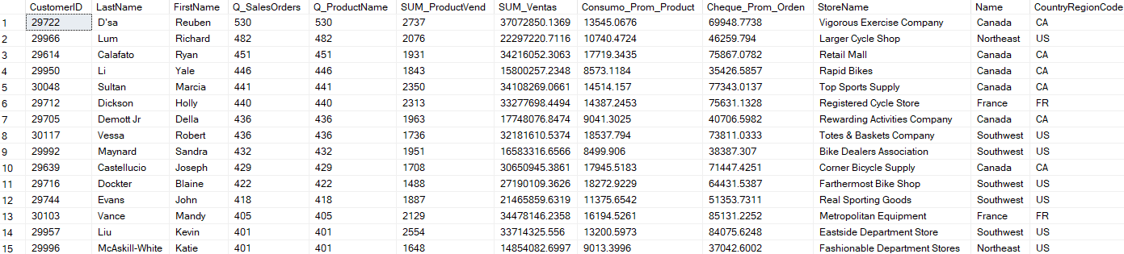

### **Sub-questions**

#### 01

* + **What is the total revenue/profit?**

**/*This query gives me the Big Picture of the monthly accumulated income (Sales) history*/**

SELECT

--YEAR(soh.OrderDate) AS Año,

MONTH(soh.OrderDate) AS Mes,

SUM (case when year(soh.OrderDate) = 2011 then (sod.UnitPrice * sod.OrderQty)end) AS Ingresos2011,

SUM (case when year(soh.OrderDate) = 2012 then (sod.UnitPrice * sod.OrderQty)end) AS Ingresos2012,

SUM (case when year(soh.OrderDate) = 2013 then (sod.UnitPrice * sod.OrderQty)end) AS Ingresos2013,

SUM (case when year(soh.OrderDate) = 2014 then (sod.UnitPrice * sod.OrderQty)end) AS Ingresos2014

FROM

Sales.SalesOrderHeader AS soh

JOIN Sales.SalesOrderDetail AS sod

ON soh.SalesOrderID = sod.SalesOrderID

GROUP BY

/*YEAR(soh.OrderDate),*/MONTH(soh.OrderDate)

ORDER BY

Mes



* **/*This query gives me the Big Picture of the monthly accumulated Profit history*/**

SELECT

--YEAR(soh.OrderDate) AS Año,

MONTH(soh.OrderDate) AS Mes,

SUM (case when year(soh.OrderDate) = 2011 then (sod.LineTotal - p.StandardCost * sod.OrderQty)end) AS Profit2011,

SUM (case when year(soh.OrderDate) = 2012 then (sod.LineTotal - p.StandardCost * sod.OrderQty)end) AS Profit2012,

SUM (case when year(soh.OrderDate) = 2013 then (sod.LineTotal - p.StandardCost * sod.OrderQty)end) AS Profit2013,

SUM (case when year(soh.OrderDate) = 2014 then (sod.LineTotal - p.StandardCost * sod.OrderQty)end) AS Profit2014

FROM

Sales.SalesOrderHeader AS soh

JOIN Sales.SalesOrderDetail AS sod

ON soh.SalesOrderID = sod.SalesOrderID

JOIN Production.Product AS p

ON sod.ProductID = p.ProductID

GROUP BY

/*YEAR(soh.OrderDate),*/MONTH(soh.OrderDate)

ORDER BY

Mes

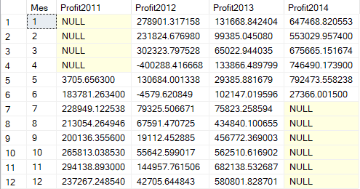

#### 02

* + **What is the average of the discounts on a single item?**

**/*Value of items that only have a discount */**

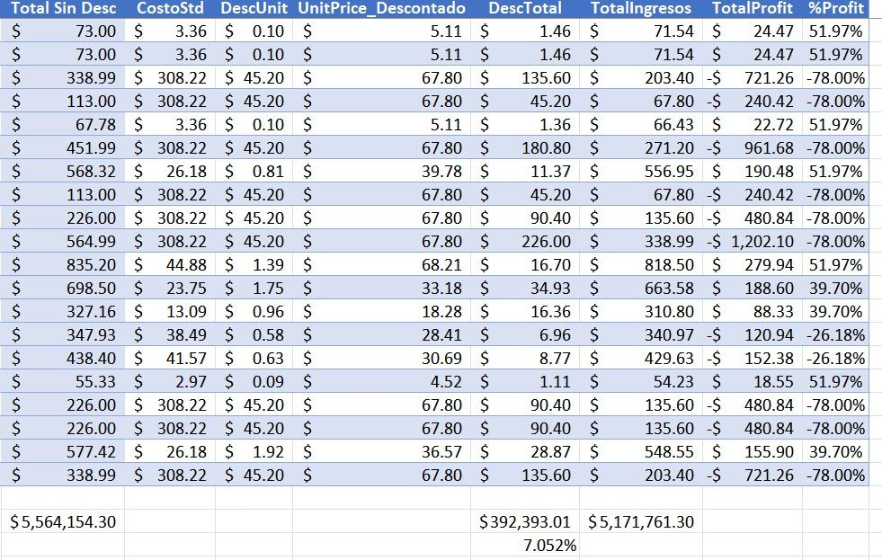

#### 03

* + **What is the quantity of items purchased?**

**/*This query returns the exact number of products sold per year*/**

SELECT YEAR(soh.OrderDate) AS Year,

SUM(sod.OrderQty) AS TotalItemsComprados

FROM Sales.SalesOrderDetail AS sod

JOIN Sales.SalesOrderHeader AS soh ON sod.SalesOrderID = soh.SalesOrderID

GROUP BY YEAR(soh.OrderDate)

ORDER BY Year;

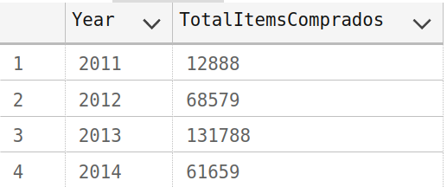

**/*This query returns the sum of all the years in products sold*/**

SELECT SUM(OrderQty) AS TotalItemsComprados

FROM Sales.SalesOrderDetail;

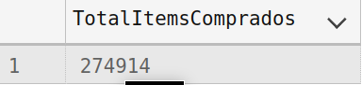

#### 04

* + **How much is the margin?**

**/*This query gives me the Big Picture of the monthly accumulated Profit history*/**

SELECT

--YEAR(soh.OrderDate) AS Año,

MONTH(soh.OrderDate) AS Mes,

SUM (case when year(soh.OrderDate) = 2011 then (sod.LineTotal - p.StandardCost * sod.OrderQty)end) AS Profit2011,

SUM (case when year(soh.OrderDate) = 2012 then (sod.LineTotal - p.StandardCost * sod.OrderQty)end) AS Profit2012,

SUM (case when year(soh.OrderDate) = 2013 then (sod.LineTotal - p.StandardCost * sod.OrderQty)end) AS Profit2013,

SUM (case when year(soh.OrderDate) = 2014 then (sod.LineTotal - p.StandardCost * sod.OrderQty)end) AS Profit2014

FROM

Sales.SalesOrderHeader AS soh

JOIN Sales.SalesOrderDetail AS sod

ON soh.SalesOrderID = sod.SalesOrderID

JOIN Production.Product AS p

ON sod.ProductID = p.ProductID

GROUP BY

/*YEAR(soh.OrderDate),*/MONTH(soh.OrderDate)

ORDER BY

Mes



**/*A sum is made of the historical profit and sale for a total of: $9,989,417.40 */**

#### 05

* + **What is the average margin?**

/*MARGIN vs SALES = 9.11% */

/*MARGIN vs COST = 10.03% */

#### 06

* + **What are the monthly and quarterly rankings for the year according to the margin?**

Quarterly: FIRST & LAST QUARTER: Most profitable, Third Quarter: HIGH REVENUES

## Secondary Queris

* **/*This query returns the countries in which the products are sold and**

**the sum of historical sales in each country*/**

SELECT

s.[Group] as Continente,

r.[Name] as Pais,

s.CountryRegionCode,

SUM(SalesYTD) as HistoricoVentas,

SUM(s.SalesLastYear) as VentasAñoPasado

FROM Sales.SalesTerritory as s

join Person.CountryRegion r

on s.CountryRegionCode = r.CountryRegionCode

GROUP BY s.[Group],r.[Name], s.CountryRegionCode

ORDER BY HistoricoVentas desc

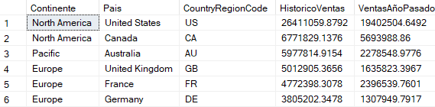

* **/*This query gives me the Big Picture of the monthly accumulated income (Sales) history*/**

SELECT

--YEAR(soh.OrderDate) AS Año,

MONTH(soh.OrderDate) AS Mes,

SUM (case when year(soh.OrderDate) = 2011 then (sod.UnitPrice * sod.OrderQty)end) AS Ingresos2011,

SUM (case when year(soh.OrderDate) = 2012 then (sod.UnitPrice * sod.OrderQty)end) AS Ingresos2012,

SUM (case when year(soh.OrderDate) = 2013 then (sod.UnitPrice * sod.OrderQty)end) AS Ingresos2013,

SUM (case when year(soh.OrderDate) = 2014 then (sod.UnitPrice * sod.OrderQty)end) AS Ingresos2014

FROM

Sales.SalesOrderHeader AS soh

JOIN Sales.SalesOrderDetail AS sod

ON soh.SalesOrderID = sod.SalesOrderID

GROUP BY

/*YEAR(soh.OrderDate),*/MONTH(soh.OrderDate)

ORDER BY

Mes

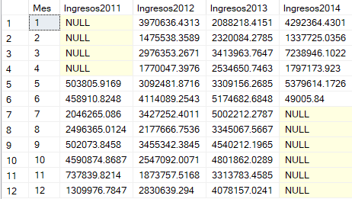

**/*Now we analyze profitability*/**

* **/*This query gives me the Big Picture of the monthly accumulated Profit history*/**

SELECT

--YEAR(soh.OrderDate) AS Año,

MONTH(soh.OrderDate) AS Mes,

SUM (case when year(soh.OrderDate) = 2011 then (sod.LineTotal - p.StandardCost * sod.OrderQty)end) AS Profit2011,

SUM (case when year(soh.OrderDate) = 2012 then (sod.LineTotal - p.StandardCost * sod.OrderQty)end) AS Profit2012,

SUM (case when year(soh.OrderDate) = 2013 then (sod.LineTotal - p.StandardCost * sod.OrderQty)end) AS Profit2013,

SUM (case when year(soh.OrderDate) = 2014 then (sod.LineTotal - p.StandardCost * sod.OrderQty)end) AS Profit2014

FROM

Sales.SalesOrderHeader AS soh

JOIN Sales.SalesOrderDetail AS sod

ON soh.SalesOrderID = sod.SalesOrderID

JOIN Production.Product AS p

ON sod.ProductID = p.ProductID

GROUP BY

/*YEAR(soh.OrderDate),*/MONTH(soh.OrderDate)

ORDER BY

Mes



* **/*This query returns the monthly historical profit to use in the dynamic table and dashboard*/**

select

YEAR(h.OrderDate) as Año,

DATENAME(MONTH, h.OrderDate) as Mes,

SUM(d.LineTotal - p.StandardCost * d.OrderQty) as lineProfit

from Sales.SalesOrderDetail d

left join Production.Product p

on d.ProductID = p.ProductID

left join Sales.SalesOrderHeader as h

on d.SalesOrderID = h.SalesOrderID

group by YEAR(OrderDate), DATENAME(MONTH,OrderDate)

order by 1,2

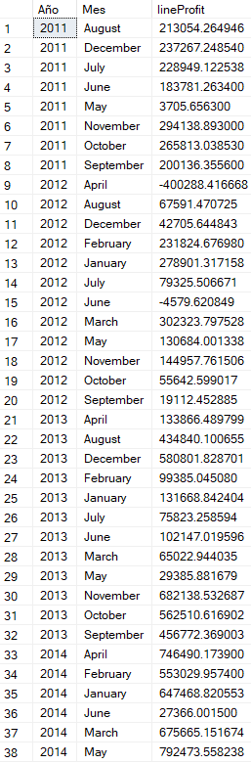

* **/*This Query returns the behavior of sales by country and by month*/**

**SELECT**

t1.Mes,

st.Name AS Region,

cr.Name AS Country,

t1.Ingresos2011,

(t1.Ingresos2012 - t1.Ingresos2011) AS 'DIFF 2011 al 2012',

((t1.Ingresos2012 / t1.Ingresos2011)-1)*100 AS '%CRECI 2011 al 2012',

t1.Ingresos2012,

(t1.Ingresos2013 - t1.Ingresos2012) AS 'DIFF 2012 al 2013',

((t1.Ingresos2013 / t1.Ingresos2012)-1)*100 AS '%CRECI 2012 al 2013',

t1.Ingresos2013,

(t1.Ingresos2014 - t1.Ingresos2013) AS 'DIFF 2013 al 2014',

((t1.Ingresos2014 / t1.Ingresos2013)-1)*100 AS '%CRECI 2013 al 2014',

t1.Ingresos2014

FROM

(SELECT

MONTH(soh.OrderDate) AS Mes,

soh.TerritoryID,

SUM (CASE WHEN YEAR(soh.OrderDate) = 2011 THEN (UnitPrice * OrderQty) END) AS Ingresos2011,

SUM (CASE WHEN YEAR(soh.OrderDate) = 2012 THEN (UnitPrice * OrderQty) END) AS Ingresos2012,

SUM (CASE WHEN YEAR(soh.OrderDate) = 2013 THEN (UnitPrice * OrderQty) END) AS Ingresos2013,

SUM (CASE WHEN YEAR(soh.OrderDate) = 2014 THEN (UnitPrice * OrderQty) END) AS Ingresos2014

FROM

Sales.SalesOrderHeader AS soh

JOIN Sales.SalesOrderDetail AS sod ON soh.SalesOrderID = sod.SalesOrderID

GROUP BY

MONTH(soh.OrderDate), soh.TerritoryID

) AS t1

JOIN

Sales.SalesTerritory AS st ON t1.TerritoryID = st.TerritoryID

JOIN

Person.CountryRegion AS cr ON st.CountryRegionCode = cr.CountryRegionCode

GROUP BY st.Name,cr.Name,t1.Mes,t1.Ingresos2011,t1.Ingresos2012,t1.Ingresos2013,t1.Ingresos2014

ORDER BY st.Name,cr.Name,t1.Mes

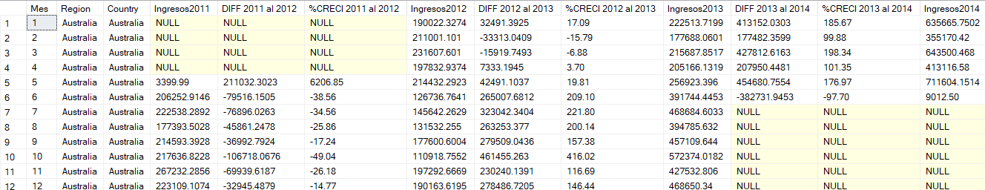

**/*This Query returns the exclusive behavior of a month comparing all countries and regions of all years. Additionally, the name of each month is included*/**

SELECT

DATENAME(MONTH, t1.Mes) AS NombreMes,

st.Name AS Region,

cr.Name AS Country,

t1.Ingresos2011,

(t1.Ingresos2012 - t1.Ingresos2011) AS 'DIFF 2011 al 2012',

((t1.Ingresos2012 / t1.Ingresos2011)-1)*100 AS '%CRECI 2011 al 2012',

t1.Ingresos2012,

(t1.Ingresos2013 - t1.Ingresos2012) AS 'DIFF 2012 al 2013',

((t1.Ingresos2013 / t1.Ingresos2012)-1)*100 AS '%CRECI 2012 al 2013',

t1.Ingresos2013,

(t1.Ingresos2014 - t1.Ingresos2013) AS 'DIFF 2013 al 2014',

((t1.Ingresos2014 / t1.Ingresos2013)-1)*100 AS '%CRECI 2013 al 2014',

t1.Ingresos2014

FROM

(SELECT

MONTH(soh.OrderDate) AS Mes,

soh.TerritoryID,

SUM (CASE WHEN YEAR(soh.OrderDate) = 2011

THEN (UnitPrice * OrderQty) END) AS Ingresos2011,

SUM (CASE WHEN YEAR(soh.OrderDate) = 2012

THEN (UnitPrice * OrderQty) END) AS Ingresos2012,

SUM (CASE WHEN YEAR(soh.OrderDate) = 2013

THEN (UnitPrice * OrderQty) END) AS Ingresos2013,

SUM (CASE WHEN YEAR(soh.OrderDate) = 2014

THEN (UnitPrice * OrderQty) END) AS Ingresos2014

FROM

Sales.SalesOrderHeader AS soh

JOIN Sales.SalesOrderDetail AS sod

ON soh.SalesOrderID = sod.SalesOrderID

GROUP BY

MONTH(soh.OrderDate),

soh.TerritoryID

) AS t1

JOIN

Sales.SalesTerritory AS st

ON t1.TerritoryID = st.TerritoryID

JOIN

Person.CountryRegion AS cr

ON st.CountryRegionCode = cr.CountryRegionCode

WHERE

t1.Mes = 1

GROUP BY

st.Name,

cr.Name,

t1.Mes,

t1.Ingresos2011

,t1.Ingresos2012,

t1.Ingresos2013,

t1.Ingresos2014

ORDER BY

st.Name,

cr.Name,

t1.Mes

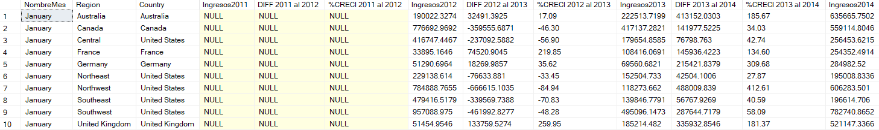

**/*This Query returns the Number of invoices and the number of products for each SalesOrderID, classified by continent, territory and Country*/**

SELECT

st.[Group] as 'Continente',

st.[Name] as 'Territorio',

cr.[Name] as 'NombrePaís',

st.CountryRegionCode as 'CódigoPaís',

DATENAME(MONTH, soh.OrderDate) as 'Mes',

COUNT (CASE WHEN YEAR(soh.OrderDate) = 2011

THEN (soh.SalesOrderID) END) as QFacturas,

SUM( CASE WHEN YEAR(soh.OrderDate) = 2011

THEN sod.OrderQty*sod.UnitPrice END) as 'ValorXFactuta',

SUM (CASE WHEN YEAR(soh.OrderDate) = 2011

THEN (sod.OrderQty) END) as QProductos

FROM

Sales.SalesOrderHeader as soh

join sales.SalesOrderDetail as sod

on soh.SalesOrderID = sod.SalesOrderID

join sales.SalesTerritory as st

on st.TerritoryID =soh.TerritoryID

join Person.CountryRegion as cr

on cr.CountryRegionCode = st.CountryRegionCode

--where YEAR(soh.OrderDate) = 2011 and cr.[Name] = 'Australia'

Group by

st.[Group],

st.[Name],

cr.[Name],

st.CountryRegionCode,

soh.OrderDate

Order by soh.OrderDate

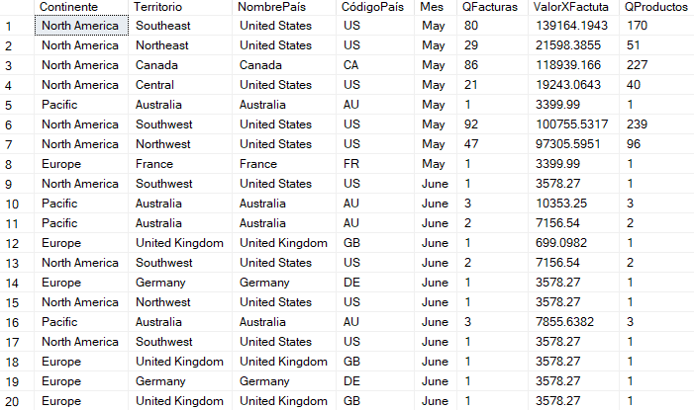

**/*This query tells me all the products that are components, because they are in an order of work. Therefore there are 238 products that are part of assemblies.*/**

Select w.ProductID,

p.[Name] as 'ProductName',

c.[Name] as 'CategoryName',

s.[Name] as 'SubCategoryName',

p.ListPrice

from Production.WorkOrder as w

join Production.Product as p

on w.ProductID = p.ProductID

left join Production.ProductSubcategory as s

on s.ProductSubcategoryID = p.ProductSubcategoryID

left join Production.ProductCategory as c

on c.ProductCategoryID = s.ProductCategoryID

group by w.ProductID, p.[Name],c.[Name], s.[Name],p.ListPrice

order by c.[Name]

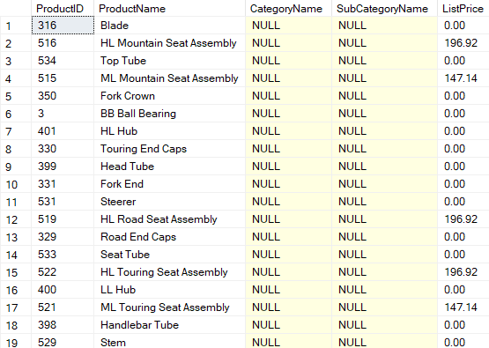

**/*This Query tells me all the products that ARE NOT PART of the WorkOrder table,**

**and refer more to screws, accessories, spare parts and clothing*/**

Select p.ProductID,

p.[Name] as 'ProductName',

c.[Name] as 'CategoryName',

s.[Name] as 'SubCategoryName',

p.ListPrice,

p.StandardCost,

(p.ListPrice-p.StandardCost) as Profit,

(p.StandardCost/(p.ListPrice+0.00001))*100 as '%',

SUM(i.Quantity) as 'Cantidad'

from Production.Product as p

left join Production.ProductSubcategory as s

on s.ProductSubcategoryID = p.ProductSubcategoryID

left join Production.ProductCategory as c

on c.ProductCategoryID = s.ProductCategoryID

left join Production.ProductInventory as i

on p.ProductID = i.ProductID

where p.ProductID not in

(select w.ProductID

from Production.WorkOrder as w)

group by

p.ProductID,

p.[Name],

c.[Name],

s.[Name],

p.ListPrice,

p.StandardCost,

(p.ListPrice-p.StandardCost),

(p.StandardCost/(p.ListPrice+0.00001))*100

order by c.[Name]

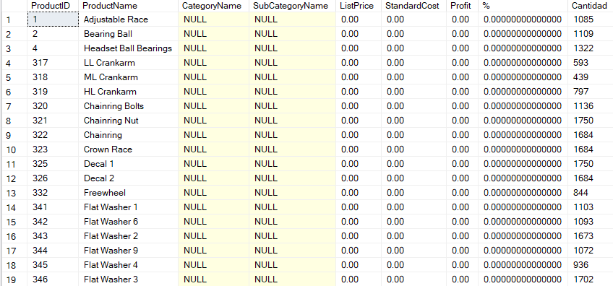

* **/*Query to analyze sales by territory, best-selling product, profitability, sales price and price difference in percentage*/**

SELECT

st.Name AS Territorio,

p.Name AS ProductoMasVendido,

MAX(pph.ListPrice) AS PrecioEmpresa,

MAX(sod.UnitPrice) AS PrecioVenta,

(MAX(sod.UnitPrice) - MAX(pph.ListPrice)) / MAX(pph.ListPrice) * 100 AS DiferenciaPrecioPorcentaje

FROM Sales.SalesOrderDetail as sod

JOIN Sales.SalesOrderHeader as soh ON sod.SalesOrderID = soh.SalesOrderID

JOIN Sales.SalesTerritory as st ON soh.TerritoryID = st.TerritoryID

JOIN Production.Product as p ON sod.ProductID = p.ProductID

JOIN Production.ProductInventory as pinv ON p.ProductID = pinv.ProductID

JOIN Production.ProductListPriceHistory as pph ON p.ProductID = pph.ProductID

WHERE soh.OrderDate BETWEEN '2011-01-01' AND '2014-12-31'

GROUP BY

st.Name,

p.Name

ORDER BY

st.Name,

MAX(sod.OrderQty) DESC

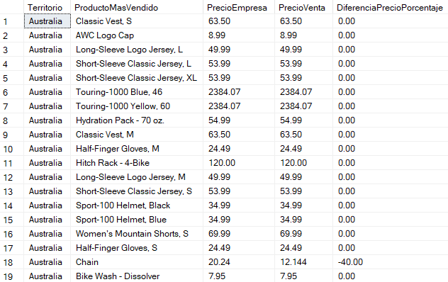

**/*This query is improved than the previous query since there are calculation values that do not match, also the number of invoices was discarded since when joining with the detail it was counting the number of items detailed in each invoice and not the number of invoices*/**

SELECT

SC.CustomerID,

CONCAT(PP.[LastName],' ',PP.[FirstName]) AS Cliente,

SUM(SSOD.OrderQty) AS Q_ProductVend,

SS.[Name] AS StoreName,

SST.[Name],SST.CountryRegionCode

FROM

Sales.Customer SC

LEFT JOIN Person.Person PP

ON SC.PersonID = PP.BusinessEntityID

LEFT JOIN Sales.SalesOrderHeader SSOH

ON SC.CustomerID = SSOH.CustomerID

LEFT JOIN Sales.SalesOrderDetail SSOD

ON SSOH.SalesOrderID = SSOD.SalesOrderID

LEFT JOIN Production.Product PROD

ON PROD.ProductID = SSOD.ProductID

LEFT JOIN Sales.SalesTerritory SST

ON SST.TerritoryID = SC.TerritoryID

LEFT JOIN Sales.Store SS

ON SC.StoreID = SS.BusinessEntityID

/*WHERE SST.CountryRegionCode = 'CA' AND YEAR(SSOH.OrderDate) = 2012*/

WHERE PP.LastName IS NOT NULL

GROUP BY

SSOH.SalesOrderID,

SC.CustomerID,PP.[LastName],PP.[FirstName],

SS.[Name],

SST.[Name],SST.CountryRegionCode

ORDER BY

Q_ProductVend DESC, SC.CustomerID,PP.[LastName] ASC, PP.[FirstName] AS

# 

# 

# 

# 

# 

# 

# 

# 

# 

# 

# CONCLUSION

The specific functions and procedures offered by the database were explained. This includes SQL queries, in which each code details what it is used for with its respective screenshot. It is seen that there was a lot of data and queries divided as main and secondary queries. The database was very flexible for each query